
SEMESTER TWO 2017

YEAR 12, Units 3 & 4

MATHEMATICS METHODS

Section One – Booklet 1
(Calculator–free)

Name: _________________________________

MAW | VMU | MPC | AGC
Circle your Teacher:

TIME ALLOWED FOR THIS SECTION

Reading time before commencing work: five minutes
Working time for section: fifty minutes

MATERIAL REQUIRED / RECOMMENDED FOR THIS SECTION

To be provided by the candidate
Standard items: pens, pencils, pencil sharpener, highlighter, eraser, ruler.

IMPORTANT NOTE TO CANDIDATES
No other items may be taken into the examination room. It is your responsibility to ensure
that you do not have any unauthorised material. If you have any unauthorised material with you, hand it to the supervisor before reading any further.

To be provided by the supervisor

Question/answer booklet for Section One.
Formula sheet which may also be used for Section Two.
Structure of this examination

 | Number of questions available | Number of questions to be answered | Working time (minutes) | Marks available | Percentage of exam
Section One  Calculator—free | 9 | 9 | 50 | 50 | 35
Section Two  Calculator—assumed | 12 | 12 | 100 | 86 | 65
Total marks |  |  |  | 136

Instructions to candidates

1. The rules for the conduct of the Western Australian external examinations are detailed in the Year 12 Information Handbook 2017. Sitting this examination implies that you agree to abide by these rules.

2. Write your answers in the Question/Answer booklet.

3. You must be careful to confine your answers to the specific questions asked and to
follow any instructions that are specific to a particular question.

4. Spare pages are provided at the end of this booklet. If you need to use them, indicate
in the original answer space where the answer is continued i.e. give the page number.

5. Show all your working clearly. Your working should be in sufficient detail to allow your
answers to be checked readily and for marks to be awarded for reasoning. Incorrect
answers given without supporting reasoning cannot be allocated any marks. For any
question or part question worth more than two marks, valid working or justification is
required to receive full marks. If you repeat an answer to any question, ensure that you
cancel the answer you do not wish to have marked.

6. It is recommended that you do not use pencil, except in diagrams.

7. The Formula Sheet is not to be handed in with your Question/Answer booklet.

This page has intentionally been left blank.

Question 1 (3+3+2+2 = 10 marks)

Differentiate, simplifying and leaving your answers with positive indices where appropriate:

a)

b)

Question 1 continued

c)

d)

Question 2 (3+3 = 6 marks)

Use calculus to determine the following indefinite integral.
a)

Use Calculus to determine the exact value of each of the following.
b)

Question 3 (2+3 = 5 marks)

a) Determine

b) Hence or otherwise, calculate the exact value of

Question 4 (4+2 = 6 marks)

The discrete random variable X represents the outcome on a spinner. The probability distribution of X is displayed in the table below.

x | 0 | 1 | 2 | 3 | 4
P(X=x) | 2n | n | m | m | 0.1

a) Given that E(X) = 2 determine the values of m and n.

b) E() = 5.6 determine the value for Var(Z), where Z

Question 5 (2+3 = 5 marks)

Given that the and the , express each of the following in terms of p and k.

a)

b)

Question 6 (4+3 = 7 marks)

a) Solve , giving exact answer(s).

b) Express y in terms of x if , simplify your answer.

Question 7 (2 marks)

Determine the equation of the graph shown below.

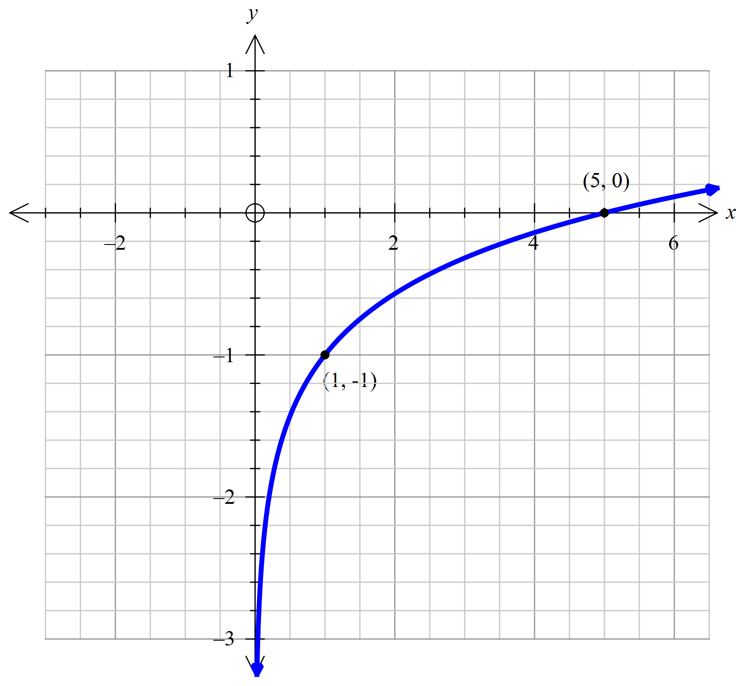

Question 8 (3 marks)

Determine the exact value of the x-intercept for the function defined by

Question 9 (6 marks)

A random variable X has a mean of and a probability density function:
for , determine the values of k and a.

End of Questions for Booklet One
Spare Working Page

Spare Working Page

Spare Working Page

